Geometry: Unit 7, Lesson 4
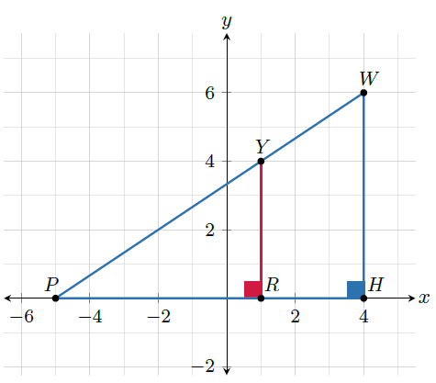
- $∆WPH$ and $∆YPR$ shown are right triangles. What angle do $∆WPH$ and $∆YPR$ have in common.

$$∆WPH$$

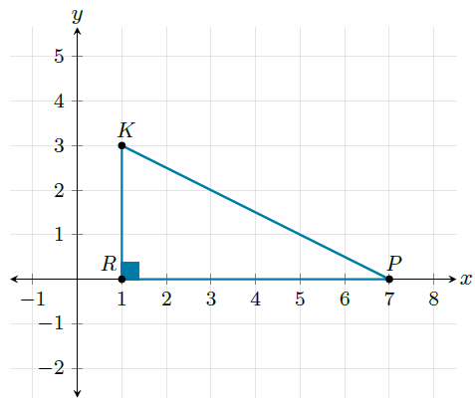
- Right triangle $∆RKP$ is shown on the coordinate plane where $m∠KRP=90°$ and $m∠KPR=26°$. What is the $m∠RKP$?

$$64°$$

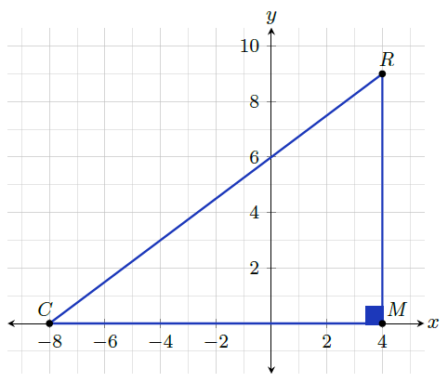
- Right triangle $∆CRM$ is shown on the coordinate plane. What is the ratio of the cosine of $∠C$?

$$\frac{12}{15}$$

